**Title of the study IN ENGLISH presented on the 15th International Conference of Doctoral Studies in Field of Education of Natural Sciences (Times New Roman 14, bold, centered)**

**Title of the study in language of the study if it is different from English (Times New Roman 14, bold, centered, This part is not required in case of studies written in English language.)**

**FirstauthorTheStudent1, SecondauthorSupervisor2, (Times New Roman 11, bold, centered)**

1Department of chemistry, Pedagogy Faculty, J. Selye University, Komárno, Slovak Republic

2Department of Physical Chemistry, Faculty of Natural Sciences, Comenius University in Bratislava, Slovak Republic (Times New Roman 10, normal, centered)

e-mail: corresponding_author@email.com (Times New Roman 10, normal, centered)

Abstract (in English):

Abstract in English should be **no more than 500 characters**(with spaces), formatted in Microsoft Word, and single-spaced, using size 10 Times New Roman font.

It should have an intro, body and conclusion. It is a well-developed paragraph, should be exact in wording, and must be understandable to a wide audience.

Keywords: (max. 5- in English)

Keywords_1, keywords_2, keywords_3

Abstrakt (in language of the study if it is different from English – slovak/

czech/ hungarian, this part is not required in case of studies written in English language.):

Abstract in original language of the study should be no more than 500 characters (with spaces), formatted in Microsoft Word, and single-spaced, using size 10 Times New Roman font.

Keywords: (max. 5- in language of the study, this part is not required in case of studies written in English language)

Keywords_1, keywords_2, keywords_3

1. Introduction

General recommendations for the format of the paper. The studyshould be typewritten for A4 format paperand **the full text range no more than 30 000 characters (with spaces).** The text is single-spaced, using size 12 Times New Roman font.

1. Theoretical background

Figures and Photos: Paper may include figures, graphs and tables. A caption should be attached to each figure. Figure captions should be centered below the figures; table captions should be centered above. See examples below.

The image should be in *.jpg or *.png format with a resolution of at least 400 dpi attached in separately files labeled for example „Fig_01.jpeg”.

Xxxxxxxxxx xxxxx xxxxx xxxxxxxx xxxxxxxx xxxxxxx xxxxxx xxxxxx xxx xxxxx xxxxxx xxxxxxxx xx xxxx xxxxx xxxxxx xxxxx xxxxxx xxxxx xxxxxx xxxx xxx x xxxxxx xxxxx xxxxx xxxxxxx xx xxxxx xxxx xxxxx xxxxxx xxxx xxx xx.

Table 1. Title of the table

|  |  |  |  |
| --- | --- | --- | --- |
|  | Title 1 | Title 2 | Title 3 |
| One | 1 | 2 | 3 |
| Two | 4 | 5 | 6 |

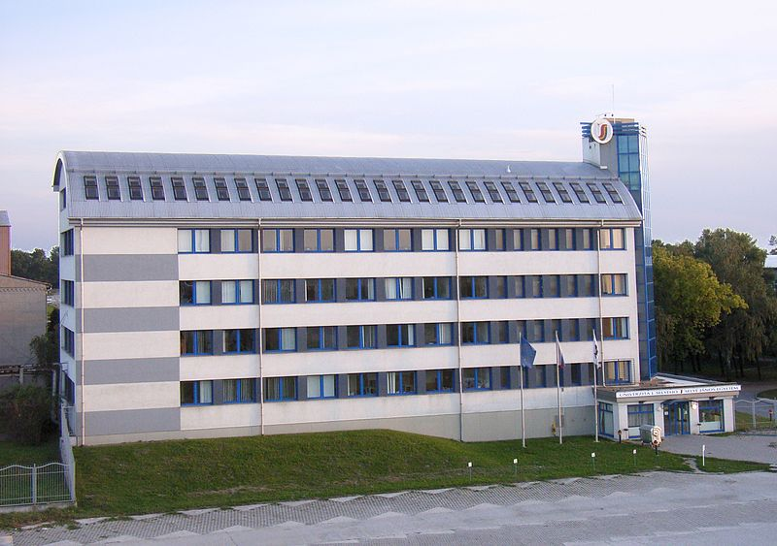

Figure 1 Title of the figure

Xxxxxxxxxx xxxxx xxxxx xxxxxxxx xxxxxxxx xxxxxxx xxxxxx xxxxxx xxx xxxxx xxxxxx xxxxxxxx xx xxxx xxxxx xxxxxx xxxxx xxxxxx xxxxx xxxxxx xxxx xxx x xxxxxx xxxxx xxxxx xxxxxxx xx xxxxx xxxx xxxxx xxxxxx xxxx xxx xx

1. Research characteristics (objective, research methods and tools, sample description, etc.)

References should be made at the end of the paper. References are listed alphabetically. For citation of references in the text of the paper, the name (first entry) is enclosed in brackets, followed by a comma followed by the date of publication of the document (Black, 2015), (Black & White, 2016), (Black et al., 2017). References should be cited according to bibliography and citation style: APA. Examples of the format to be used are given below.

Xxxxxxxxxx xxxxx xxxxx xxxxxxxx xxxxxxxx xxxxxxx xxxxxx xxxxxx xxx xxxxx xxxxxx xxxxxxxx xx xxxx xxxxx xxxxxx xxxxx xxxxxx xxxxx xxxxxx xxxx xxx x xxxxxx xxxxx xxxxx xxxxxxx xx xxxxx xxxx xxxxx xxxxxx xxxx xxx xx.

1. Results

Xxxxxxxxxx xxxxx xxxxx xxxxxxxx xxxxxxxx xxxxxxx xxxxxx xxxxxx xxx xxxxx xxxxxx xxxxxxxx xx xxxx xxxxx xxxxxx xxxxx xxxxxx xxxxx xxxxxx xxxx xxx x xxxxxx xxxxx xxxxx xxxxxxx xx xxxxx xxxx xxxxx xxxxxx xxxx xxx xx.

1. Conclusions

Xxxxxxxxxx xxxxx xxxxx xxxxxxxx xxxxxxxx xxxxxxx xxxxxx xxxxxx xxx xxxxx xxxxxx xxxxxxxx xx xxxx xxxxx xxxxxx xxxxx xxxxxx xxxxx xxxxxx xxxx xxx x xxxxxx xxxxx xxxxx xxxxxxx xx xxxxx xxxx xxxxx xxxxxx xxxx xxx xx.

Xxxxxxxxxx xxxxx xxxxx xxxxxxxx xxxxxxxx xxxxxxx xxxxxx xxxxxx xxx xxxxx xxxxxx xxxxxxxx xx xxxx xxxxx xxxxxx xxxxx xxxxxx

Acknowledgements:

It is not mandatory. Times New Roman, 12 pt, Italic. After the main text and before the references. Examples of the format to be used are given below.

*This work was supported by National Grant no. ….*

References

[1] Last, F. M., & Last, F. M. (Year Published). Article title. *Journal Name*, *Volume*(Issue), pp. Pages.

[2] Last, First M. *Book Title.* City: Publisher, Year of publication.

[3] Last, F. M. (Year Published). Title of chapter In F. M. Last Editor (Ed.), *Title of book / anthology / conference proceedings* (pp. Pages). Publisher City, State: Publisher.

[4] Wikimedia (2016). *Štruktúra článku formátovaného dle IMRAD.* Retrieved 02 05, 2018, from <https://upload.wikimedia.org/wikipedia/commons/7/75/Wineglass_model_for_IMRaD_structure..png>